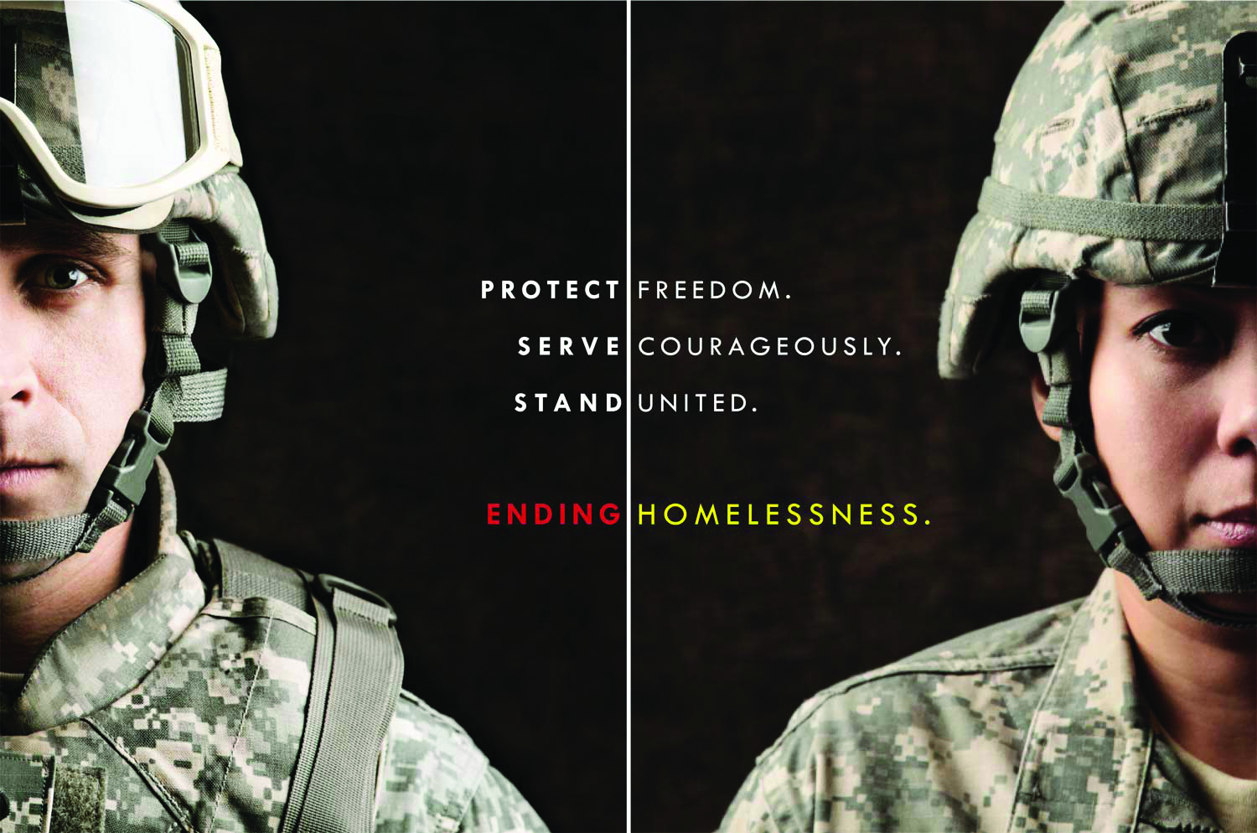

Are you a Veteran or know one who is homeless or at risk of losing their housing in Contra Costa County?
Contact (925) 957-7592, or visit ssvf@shelterinc.org

